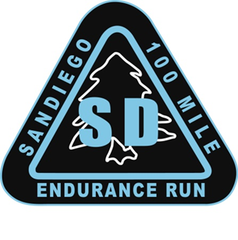
Overview
Welcome
On behalf of the Race Directors, Volunteers, and Sponsors, welcome to the Annual San Diego 100 Mile Endurance Run (SD 100). The SD 100 was founded by Paul Schmidt in 2001 and then handed to Scotty Mills who handed it to us. We are proud of the history of the race and continue to strive to maintain the quality and vibe established by both of these great RD’s.
Yes, this is 42 pages. However, everything you need to successfully complete the race is here. Feel free to skip the parts that don’t pertain to you. That‘s what the scroll thingy on your mouse is for. But do take your time going through this Handbook. It will be obvious to us if you did not. To the extent you still have questions after reading this, by all means, please reach out to us via e-mail and let us know. We’re happy to try to get you any information you want or need.
We’re committed to do our best to help prepare you to successfully run a tough and challenging 100 miles in the beauty of the San Diego east county mountains. We look forward to another great race in the east county mountains of San Diego.

Race Location/Directions
The San Diego 100 starts and finishes at Lake Cuyamaca located 9 miles south of Julian, CA. The south parking lot of Lake Cuyamaca serves as the race venue for packet pickup, check-in and the pre-race briefing. Lake Cuyamaca is located at: 15027 Highway 79, Julian, CA 92036. Directions Link: goo.gl/QGr4JH
Registration / Qualification
Cancellation Policy: If for any reason the event is cancelled due to an act of nature or other Forest Service permit issues, the race director will make every effort to refund all unobligated funds to entrants or rollover entry fees to a rescheduled race date. Entrants must accept the fact that there are risks involved in staging an ultra in the wilderness, and there are no guarantees that all entry fees will be refunded if the run is not held as advertised.
Qualification to Apply: To apply for the race each year, applicants must have completed an official 50 mile race within a 13-hour time limit. A 100K or a 100 mile race within the race finishing time also serves as an acceptable qualification. The results of the qualification must be verifiable on Ultrasignup or annotated on an official web site of the race used for qualification.
As a requisite for participation, entrants are required to volunteer 6-hours towards trail maintenance, or volunteer work at any running or community service event. This requirement must be completed and certified to the Race Director by mail or email to sandiego100rd@gmail.com once the service is completed.
A list of completed volunteer service completions is maintained and updated weekly.
In lieu of completing trailwork (or in addition!), a runner may donate $100 to support SURF, trailwork, and our volunteers. A donation goes to support Trailfit, our local trail maintenance organization, to ensure that the trails in our mountains are well maintained. Ken Bonus and his crew do a fantastic job, and a donation goes to ensure that they have the resources they need, including equipment and training.
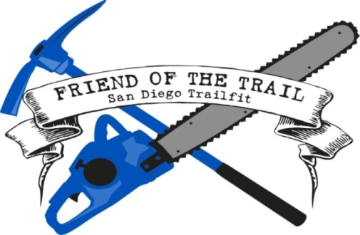
We hope and encourage the greater San Diego area SD 100 participants to complete their volunteer service in the east county San Diego trails we use for the 100 miler. Information about the San Diego Trailfit program and how to sign up for a workday are located at https://www.sdtrailfit.org .
Entry Fee / Refunds: Entry to SD 100 is $325 plus the Ultra Signup fee (approximately $20). If an entrant withdraws from the event and notifies the race director prior to April 15, they are entitled to receive a 50% refund minus the Ultrasignup fees. No refunds after April 15. No rollovers or transfer of entries once an applicant is a confirmed entrant unless a runner becomes pregnant for which we will gladly roll over an entry into the following year.
Solo Division
- Entrants declare their intent to enter the Solo Division (S) when they register. Anyone can change to Solo or Supported before May 20 by notifying the RDs. After that time, there will be no changes, and a Solo runner must run Solo.

- Solo Division runners are not allowed to have crew or pacers assist them throughout the race. They rely solely upon the official aid stations and their drop bags.

- Solo Runners are not allowed to have spectators at any aid station other than the start and finish, and as such, will not be given a pacer bib or crew vehicle placard at check-in.

- Solo Runners are allowed to run with other runners and/or their pacers but cannot rely on them (other than in an emergency) for support.

- If entrants violate the Solo Division Rules, they are not disqualified from the race but will no longer be recognized as a Solo Division finisher.

- All Solo Runners will wear a wristband to distinguish them in the Solo category. Solo runners will not receive a crew pass or pacer bib at check in since they have no access to either.

- Runners may not change to supported during the race. SOLO finishers will be awarded special award the SOLO FINISHER Belt Buckle for their accomplishment of tackling the 100 mile course unassisted.

Lodging / Camping / RV’s
Lake Cuyamaca, Cuyamaca Rancho State Park, and Julian, CA are very popular vacation destinations in early and mid-June. Make your reservations early in your planning or you may have difficulty finding lodging for race weekend.
Lake Cuyamaca has rental facilities for campsites and RV's. Several of the cabins and condos are already reserved to accommodate weekend volunteers; however, there are a few available if you reserve early. Reservations and deposits are for staying at Lake Cuyamaca: www.lakecuyamaca.org. Or you can call at 760-765-0700 for reservations. Be sure to let them know you are with San Diego 100.
There are several lodging options available in the nearby town of Julian, which is only 9 miles from the start. The Julian Chamber of Commerce website has many possibilities: http://www.visitjulian.com.
Cuyamaca Rancho State Park (Paso Picacho Campground) is only 3 miles from Lake Cuyamaca and has campsites and cabins to rent: http://www.reserveamerica.com
Also, check out Mt Laguna Lodge for accommodations in the Mt Laguna Recreational Area section of the race (about 18 miles from Lake Cuyamaca but near many of the middle aid station locations): www.lagunamountain.com
Another popular option is the Ayres lodge in Alpine, which is approximately 30 minutes from the start. Official Site | Ayres Lodge Alpine (ayreshotels.com)

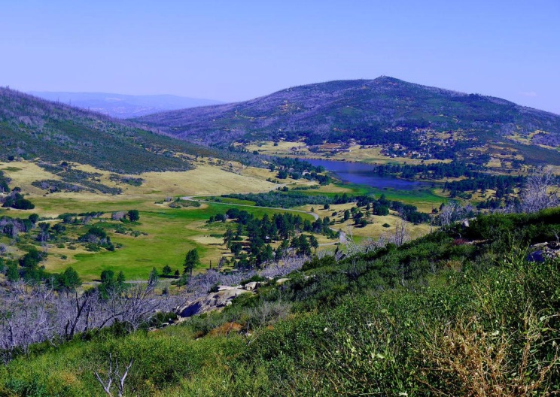

Schedule of Events for 2024

Thursday, June 6, 2024
- 3:00 pm to 5:30 pm: Optional pre-race check-in and bib pick up at Lake Cuyamaca south parking lot. Please note that if you pick up your bib early, you will still be required to check in on race morning so we know that you are on course.
Please note that there is no in-person briefing. However, there is a mandatory video briefing. Once the updated briefing is ready, there will be a link on our website, and all runners will receive an e-mail updating everyone that the briefing is ready to be viewed. WATCHING THIS BRIEFING VIDEO IS MANDATORY. There will be a secret password somewhere in the video, and you will need that password to pick up your bib.
On Thursday, June 6, at least one of the RDs will be onsite to answer your questions if you have any. There also will be several other volunteers who are valuable sources of information.

Friday, June 7, 2024
- 4:30 am - Check in and bib pick up to get last-minute details, pick up your bib, and deposit drop bags. ARRIVE EARLY - PARKING IS EXTREMELY TIGHT! The later you arrive, the further you will have to walk to get to the start. There is no parking along Hwy 79, so if you arrive late, you will have to walk upwards of a half mile from an available and legal parking location. If you are just dropping off a runner, you will not be allowed to enter the lot, but you can drop your runner off at the entrance to the parking lot for a short walk to the start. You must check-in, even if you got your bib the day before! We need to know who is on the course for your safety. REMEMBER, YOU MUST KNOW THE SECRET WORD FROM THE BRIEFING VIDEO TO GET YOUR BIB.
- 5:15 am: All Drop Bags must be deposited at the appropriate aid station bin next to the Registration Tent. Drop bags that do not meet the 16 x 12 x 6 size limitations will not be accepted. Drop Bags will be organized by number and aid station, so please pay attention to where you leave your Drop Bag. Drop Bags should be labeled with runner number and aid station. Drop Bags leave the venue at 5:30 am! Drop bags will not be under cover, so they may get wet. It is unlikely in June but plan accordingly.
- 5:50 am: Final Race Briefing in front of the Start Banner.
- 6:00 am: Race Start in front of Registration Tent. We will not allow any runners to start late since sweep runners will be removing marking ribbons just behind the last runner/s.

Saturday, June 8, 2024
- 12:00 am to 6:00 am: Sub-24 hour finishers arrive at finish line and receive their SUB-24 hour buckles.
- 6:00 am to 2:00 pm: Sub 32-hour finishers receive their FINISHER buckles.
- 6 AM. Beginning of food service and party at finish line.
- Solo Runners who finish under 32 hours receive SOLO buckle.
- Light food and refreshments will be served beginning midnight Friday with more hearty fare beginning at 6 AM until the event ends. Runners will receive a free meal and drinks, but food and drinks will be available for purchase for everyone. We encourage everyone to relax, have fun, and enjoy seeing the runners achieve their dreams.

Saturday, June 15

Post Race Fiesta! – This will be at Hopnonymous Brewery from 1 – 4 PM. https://goo.gl/maps/difHaiK5aMKAXTpe8

First beer is on us if you wear your official SD 100 swag. We encourage you to buy your volunteers a beer as many of them will be there with you to share stories and good times.
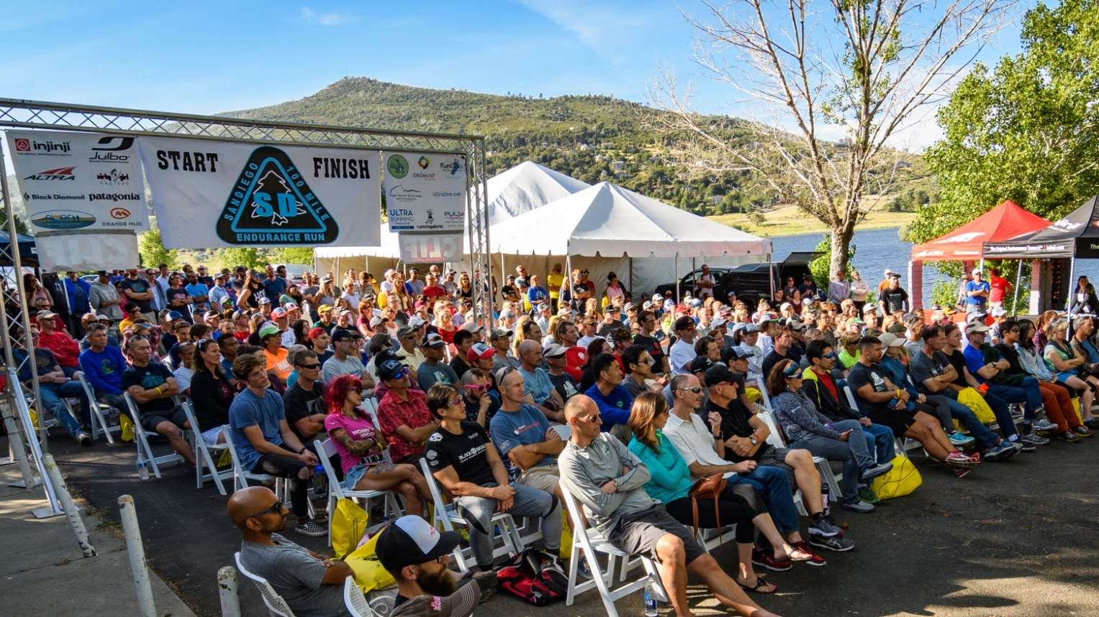
Race Rules

Getting Lost, Cutting the Course, and Cut Off Times
- SD 100 is a “Closed Course” You must follow the official course or you are not an official finisher.
- If any runner gets lost or cuts the course, they’re required to return to the point at which they went off course by their own means and continue the run from that point. If a runner does not return to that point or continues on after cutting a section of the course, they are disqualified.
- Runners who do not make the mandatory cut off times as written on the Course Information Chart are also DQ'd. The Aid Station Captain exercises the authority of the Race Directors and have earned our complete confidence. Most if not all have finished the race at least once if not multiple times. They have the authority to pull a runner from the race if they feel it is unsafe for the runner to continue. Please do not argue with the aid station captain's decisions. If an Aid Station Captain determines that it is unsafe for you to continue, you must surrender your race bib. Arguing with the Aid Station Captain may result in the runner not being allowed to participate in any future San Diego 100 or San Diego Slam race.
- Dropping out of the race: If a runner drops from the race for any reason, it is the runner's sole responsibility to personally notify the nearest aid station captain that he or she is withdrawing from the race. The runner is also required to physically remove and give their race bib to the aid station captain. Failure to notify an aid station that you are out of the race and failure to turn in your bib # may result in costly search and rescue measures which will be the responsibility of the runner.
- YOU CANNOT DROP AT WATER-ONLY STATIONS. These are located at Blue Ribbon and Big Oak. This is because we do not have runner tracking checks at these stations and may be unmanned. You must proceed to the next full aid station to drop.
- Failure to abide with any of the rules or decisions of the aid station captain will result in you not being allowed to participate in any future SD 100 or San Diego Slam race.

Littering
Dropping litter anywhere on the course is strictly prohibited. Carry all trash to the next aid station and dispose of it in the appropriate receptacles.
If you happen to see a gel pack or other race related litter that was accidentally dropped, please pick it up for us and dispose at next aid station. Thank you for keeping our trails litter free!

Relieving Yourself

If you must relieve yourself, get off the trail and out of sight. Bury and cover solid waste and toilet paper properly. LEAVE NO TRACE! There are bathrooms or porta-potties at Lake Cuyamaca, Green Valley, Sweetwater, Penny Pines, Meadows, Red Tailed Roost, and Pioneer Mail.

Medical Issues/Safety
You are responsible for your own safety. We have a medical director and will have medical care volunteers during the run. We have trained several people at our expense in CPR and wilderness first aid at the various aid stations to try to ensure your safety. With that being said, ultimately, again, YOU ARE RESPONSIBLE FOR YOUR OWN HEALTH AND SAFETY. In case of an emergency, we will endeavor to get local emergency personnel to an injured runner (or vice versa) as soon as possible. We have had long discussions with local first responders about the best way to do this, but due to the remoteness of the course, this could take hours. This is an event with risks. Please thoroughly read the registration waiver and recognize it is up to you to make wise decisions with regards to health and safety. A finish is not worth a hospital stay. Or worse.
The race has liability insurance only. This insurance does not cover medical costs incurred by the runner. If you do not have medical insurance, we recommend you join USATF. This race is sanctioned and insured by USATF and members may be able to be reimbursed for medical costs (with a cap of about $6k) if the medical condition was not due to negligence on the part of the runner. For more information, check out USATF’s on line web site.
Finally, and we can’t believe we have to actually write this, but the parks have asked us to include this section - please let us know if you see a runner in distress or, better yet, help them out if you can! When you do report to us, please do your best to get a location through a GPS pin or mileage from the aid station or trail junction (not “by a big rock”) and the runner number and what he or she is wearing.

Pets
For liability insurance purposes and permits, dogs that are not fully (and truly) licensed service dogs are not allowed at aid stations or on the course. Dogs will be allowed in a very restricted area in the shade away from the runners at the start finish venue. This rule will be strictly enforced. Dogs are also not allowed on Cuyamaca Rancho or Anza Borrego trails. It is the runner's responsibility to brief and inform your crew and/or spectators of this restriction. This has in the past resulted in penalties for the runners.
Beyond all this, it is likely going to be hot during the race, and you will be endangering your fuzzy friend by bringing him or her to the race as a car is not a great place for a dog during the summer and it will get very hot out there. Do your dog and runner a favor and leave the pups at home.
Smoking
Please no smoking at aid stations or the start finish venue.
Course Information
- The SD 100 course covers 5 major areas: Lake Cuyamaca, Rancho Cuyamaca State Park, Mt Laguna Recreational Area, Pacific Crest Trail (PCT), and the Noble Canyon and Indian Creek Trails.
- The trails are under the jurisdiction of the US Forest Service Descanso District (45%), the California Rancho Cuyamaca State Park (50%), and the Lake Cuyamaca Recreational Area (5%).
- The course is approximately 80% single track trails, 17% forest service roads and 3% asphalt road. There are many technical and rocky sections. The PCT sections total about 20 miles of the course. The overall elevation climb and descent are approximately 13,000 feet each.
- Pay very close attention to applicable course markings and review the overall course map so as to have the big picture of the course. While the course will be excellently marked, there have been instances of course marking vandalism in past races. As such, we recommend downloading the GPX file, carrying a copy of the course maps and/or detailed route directions for sections that you are unfamiliar with. Moreover, there are course videos which show all major turns on the course (and some not-so major). Do yourself a favor and check these out along with the maps and turn by turn directions (the video link is below). You will stand a much better chance of finishing or meeting your goals if you take these simple preparations.
- (10) Cliffs and Meadows - YouTube

Aid Station Chart
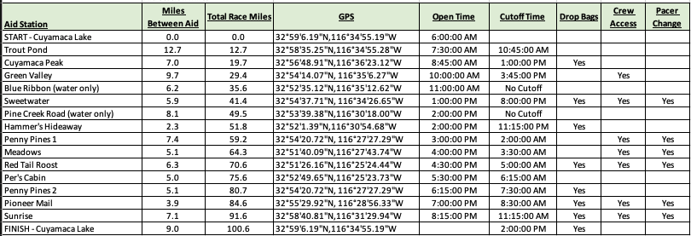
Please keep in mind that water-only stations will be unmanned, and runners cannot drop at these stations.
Cutoff times will be enforced; however, given the course is new in 2024, if a large number of runners (25% or more) have not made a cutoff, there will be consideration of an extension of the cutoff at the RDs’ discretion. Please note however that this is extremely unlikely, and runners should not count on any cutoff extension being granted. The aid station captains have been instructed to STRICTLY ENFORCE cutoffs, as sweepers begin pulling course marking immediately after the cutoff.
Shuttle Schedule
There will be a shuttle to pick up dropped runners and return them to the start/finish line; however, in most cases, it will not be scheduled to come to the aid station until after the station closes. Closing times are posted in the aid station chart. It will make unscheduled stops as time allows. As such, if you have a crew, and you drop at a crew accessible station, this will be a much better option for you. If your crew gives you a ride out, you will likely be asked to take another dropped runner with you. We appreciate in advance your willingness to help out your fellow runners!
Course Maps
Please be sure to view the Course Maps tab on our website for detailed maps, a downloadable GPX file, and turn-by-turn directions. The below is just meant as an overview. We highly recommend viewing the videos created by our Course Director and reading the turn-by-turn directions, which identify key turns. While this is not a navigation test, given the GPX files, turn-by-turn directions, maps, and videos, we do expect runners to do their homework and be able to safely navigate the course without marking in the unlikely event of course marking vandalism.
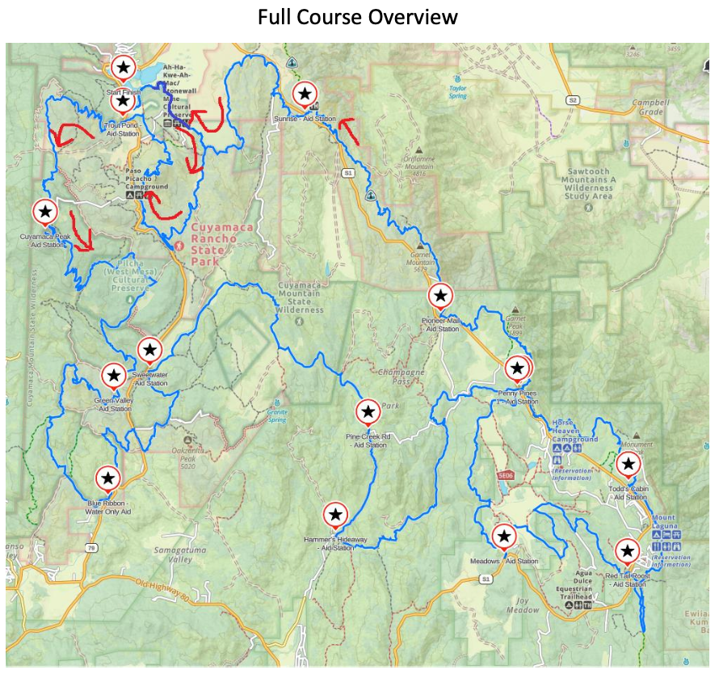
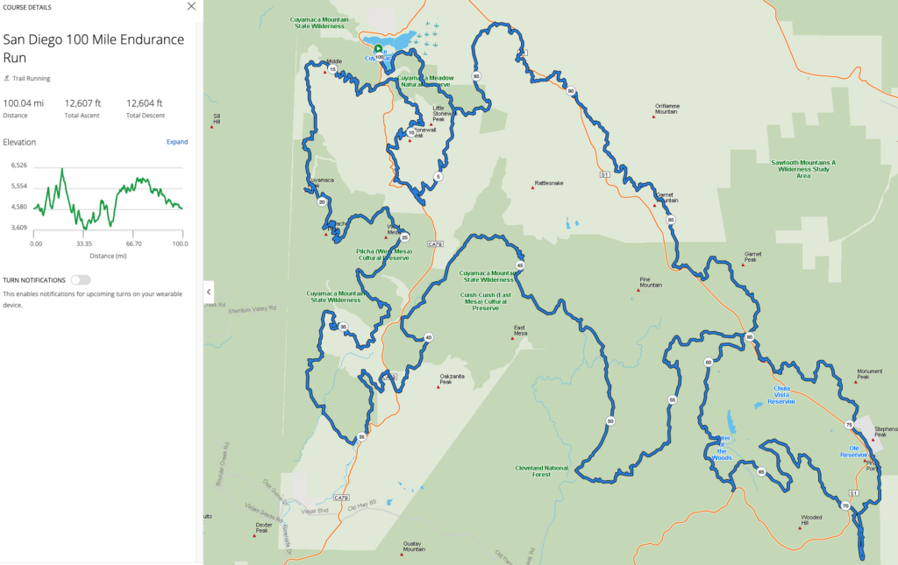
Walk Through Description
Start to Trout Pond (12.5 miles)
The race begins with a nice mile run on a tight single track through a meadow around the lake. NO PASSING FOR THE FIRST HALF MILE. Once you get to the picnic tables, there is room to pass. You will enjoy a nice run around the lake, making a left turn onto Stonewall Grade road and starting a big loop around Stonewall Peak, culminating in climbing to the top of it. After following Soapstone Grade and then Stonewall Creek fire road for a few miles, look for a hard right onto Cold Spring Trail, one of the best trails in all of San Diego County. After a very pleasant climb and descent, you make a right onto Cold Stream Trail, which is not one of the best trails in all of San Diego County, but make the best of it as you have a long grind up Cold Stream and Stonewall Peak. Over the top, it is a very technical descent down the backside of Stonewall, then a short run through the meadows before CAREFULLY crossing Hwy 79 to Trout Pond Aid Station, where the Running Skirt crew will be excited to see you! Please note that you must stop for the cars when crossing, not vice versa. Please also note that it is 12.5 miles to first aid; however, it should be relatively cool. Plan accordingly.
Trout Pond to Cuyamaca Peak (7 miles)
Your second climb of the day takes you up Middle Peak with incredible views back over the lake. There is no peak, so to speak, but the fire road you’ve been climbing turns to single track and takes you downwards with views out to the west. Squint to see the ocean! You will go through 4 corners and then up Canejos almost to the top of Cuyamaca Peak for your third climb of the day. Canejos is very rocky and technical and the climb, unrelenting. You will then join the paved Cuyamaca Peak road for a short but steep final push for the summit. You will enjoy the tough love hospitality of the Zuniga Brothers and Outpost Z at the top of Cuyamca Peak to prepare you for your next section.

Cuyamaca Peak to Green Valley (10 miles)
It will start to warm up as you enjoy some long downhill from the highest point on the course down to Green Valley. The first few miles are on beautifully smooth trails through a veggie tunnel that has changed dramatically since a fire tore through and burned most of the big trees several years ago. After dropping down almost all the way to Highway 79, you will actually do a short climb up to see Airplane Monument, a tribute to airmen who lost their lives when their plane went down in 1922. Not a bad spot to take 30 seconds and reflect. From there, it is a relatively short downhill to Green Valley aid station and Jeff Hooker’s crew who will take great care of you.
Note that crewing will be done at the Arroyo Seco Picnic area about a quarter mile before the aid station. The actual location of the aid station can vary from year to year depending on where the Park lets us set up but it will be well marked.
Green Valley to Sweetwater (12 miles with water stop)
This is a long stretch in what for many of you will be the hottest part of the day. Be sure to have PLENTY of fluids before you head out. You will be required to leave here with 70 oz., but more wouldn’t be a terrible idea.
You start with a 1.5-mile climb up Pine Ridge with a few false summits. You then roll on some fire road and single track before hitting the Saddleback Trail. Look sharp for this hard left. You will hate Saddleback. Just accept it. Trailfit has done an amazing job getting it in the shape its in, but there’s only so much you can do. Saddleback ends with what passes for a river crossing here in San Diego County. Take advantage and get wet! After the crossing, you have about a mile to an unmanned water station at Blue Ribbon to top off your fluids.
From there it is a gradual but exposed climb up Blue Ribbon (or as we drunks call it, PBR) trail and over a fire road to a small pass before you drop down to cross Highway 79. It will be busy and we will have personnel there to assist you, but you have to stop for the cars, not vice versa. After you cross, it is a short climb up to the Harvey Moore trail after which you drop down to Sweetwater Aid (finally!) and Dave and Juliet York will have the tiki bar rocking to get you back in the game.
Sweetwater to Hammer’s Hideaway (10.5 miles with water stop)
Bidding a fond farewell to the Mai Tais, you will once again be required to carry 70 oz. as you head out through beautiful, runnable meadows for the next couple of miles. For those here in the late afternoon, there is an excellent chance to see turkey and deer. You will then tackle the Harvey Moore trail, your second to last big climb! You will catch some breezes on the switchbacks as you work your way up to the high Cuyamaca meadows. From there, you will bid a fond farewell to the Cuyamacas as you run the connector trail down to the Lagunas and joining the old San Diego 100 course at the fire road where you take a right. After a few miles and a steep but short climb, you hit the water station at Big Oak (you’ll know it when you see it) followed by a fun 2 downhill miles on “pavement” to Hammer’s Hideaway.
Hammer’s is named after a long-time volunteer captained this station for years. It is expertly captained by his friend Mikster. As they help prepare you for Noble, pour a little tailwind out in Hammer’s memory. Or have a beer, as that would be much more in his spirit.
Hammer’s Hideaway to Penny Pines 1 (7.5 miles)
Fill up for your last major climb of the day! It is a long but not necessarily tough climb through Noble Canyon. It will be hot if you are here in the afternoon and suitably spooky at night! It begins as technical rolling desert but as you get into the trees, the climbing starts in earnest. You get a brief respite after crossing a paved road 5 miles in. The climbing becomes much more gradual for the last push to Penny 1 and the awesome Run Dirty crew, where you can once again see your crew and get ready for the overnight!

Penny Pines 1 to Meadows (5 miles)
A beautiful section of meadows, the trail becomes rolling, giving you a break after the long grind of Noble Canyon. Navigation here can be tricky, so please be sure to review your GPX, maps, turn-by-turn directions, etc. You will be able to hear the frogs in the various pools in the lake area, and there are places where you will have a 360-degree view. We expect most of you to be here at night. If so, please do yourself a favor and take a moment to turn off your headlight and look up at the stars! You might want to stop running before you do that. Once you make it to Meadows, the South Bay Y folks are going to give you so much good energy, you’ll be ready to float the last 35 miles.
Meadows to Red Tail Roost (6.5 miles)
The trail continues to roll, giving you time to recover, as for most of you, you are now in late-night survival mode. The course takes you back into the meadows (watch out for cows!), through a mountain bike course with lots of obstacles (optional but bonus points), and then into the forest, ending with a relatively short but steep technical climb with lots of false summits before dropping down to Red Tail Roost. You will curse our name on this climb, but stick with it and stay patient! When you think you are at the top, you aren’t! Until you are . . . Mike and Ina will make it worth your while and pamper you to no end, so don’t be tempted to stay and party with them as you still have work to do!
Red Tail Roost to Per’s Cabin (5 miles)
A 1.3 mile section of fire road brings you to the PCT where you will take a hard left towards Canada. This would be a bad turn to miss. Soon, the views start to open up over the desert, and on the right day or night, you can see all the way to the Salton Sea. The winds can really start to pick up here, so be prepared. The trail is rolling, runnable (if anything is runnable after 70 miles) but technical trail until you take a left off the PCT for a short jaunt downhill to Per’s cabin. Long time SD 100 stalwart Todd sold his cabin and Per, a longtime ham volunteer, has been generous enough to let us continue the long tradition of the station, where Enrique and Mario, long time veterans of Todd’s, will be ready to keep you moving on your PCT journey.
Per’s Cabin to Penny Pines 2 (5 miles)
The trail rolls for a bit with a decent climb (OK, the climbing isn’t entirely over) before a downward trend to Penny Pines 2. You are just across the street from where you were at mile 59 after your Noble Canyon adventure, and you are hopefully feeling just as fresh! Tracy Dimino and her squad will be waiting, probably in goofy costumes that will make you laugh, to get you all you need for the final push home.
Penny Pines 2 to Pioneer Mail (4 miles)
More fantastic single track in a relatively short rolling push to the next station where Gloria and her crew are ready to greet you with a full service crazy fun station with crew access and energy to spare to get you through your night/morning. It is going to get warm for those of you coming in after 6 AM, so be sure to leave with lots of ice and fluids if that’s you.
This next section (to Sunrise) is the most dangerous of the race. There is limited cell coverage, the winds are usually crazy, and the heat can be fierce, even in the early morning. We have had to evacuate folks off this section of the trail on multiple occasions, and it hasn’t been easy. Please do a very thorough self-evaluation and be sure you can go on before leaving this station. Gloria and her VERY experienced crew will take great care of you, but they’ve also been asked to err on the side of NOT letting you go on if they have doubts about your ability to continue given the history of this section. DO NOT leave this station unless you are feeling strong and are prepared.
Pioneer Mail to Sunrise (7 miles)
Now that we have scared the poop out of you, we can tell you that this is actually a very fun section if you are ready for it. The great desert views continue. After a short climb and crossing a paved road, you start a very gradual downhill trend. Having said that, there are plenty of pop up hills to frustrate you, and it can be rocky, so stay patient! This section will seem a lot longer than it is as the trail rolls in and out of side canyons. Again, be sure to have lots of ice and water before heading out. After about 7 miles, you say goodbye to the PCT and turn left to visit Joey, whose folks will be waiting to get you all you need for a glorious finish!
Sunrise to Finish (9 miles)
This is it! The glory ride home. You begin with a rolling section along Sunrise Hwy (crews, be sure to honk encouragement at the runners!) followed by incredible meadow running with lots of unbelievable views of Stonewall, Middle, and Cuyamaca peaks (all of which you climbed!) A great moment to reflect on your journey. Finally, you hit the fire road, close the loop, scoot around the lake and a dash for the finish. You’ll see and hear the finish line about a mile or so before you get there, so stay patient and soak it all in! You can have as many friends and family run in with you from the picnic tables to the finish, so make it a party, and congratulations!!!
Drop Bags
- Runners may have drop bags (clearly marked with runner's name, bib #, and applicable aid station) for personal needs at the designated drop bag aid stations (Cuyamaca Peak, Sweetwater, Hammers, Red Tail, Penny 2, Pioneer, and Sunrise).
- Drop bags are restricted in size to the equivalent of a large shoe box (16 x 12 x 6- this size will be strictly enforced). All bags need to be durable, waterproof, and secure.
- Your drop bags must be placed in the applicable aid station containers at the start area (Lake Cuyamaca) no later than 5:15 am race morning. These drop bags bins should be sorted by aid station and number, so make sure you are putting the bags in the right bin that matches your race number. Any bags that exceed the size limitations will not be accepted or transported. These bags may not be protected from the elements, so plan accordingly.
- Drop bags will be returned to Lake Cuyamaca approximately an hour after the applicable aid station closes. Unclaimed drop bags will not be mailed back to entrants, so PLEASE pick up your drop bags prior to leaving the venue. We leave the mountains usually 3 to 4 hours after the last runner crosses the finish line, so there is no opportunity to claim your bags after that. Unclaimed drop bag clothing and gear will be donated to charity.

- If you decide to withdraw, or finish the race prior to the drop bags being returned to Lake Cuyamaca, you or your crew can drive to the applicable aid station if it is still open and claim the bag that way.
Pacer Rules
- Pacers may accompany their runner for safety and companionship, not to lighten the load or run ahead of their runner to get supplies in advance of an aid station arrival. Pacers must check in and out of each aid station along with their runner so course monitors know they are on the course. However, there are no pacer bibs. If you want to draw your own to entertain your runner with a particularly horrific picture or something similar, go for it!

- Pacers are entitled to use all the aid and resources at aid stations but are not allowed to carry (mule) or physically assist their runner.

- Pacers are allowed to accompany a runner (one pacer at a time) beginning at Sweetwater.

- Pacers may switch at Penny 1, Meadows, Red Tail, Pioneer Mail, and Sunrise.

- Runners may have multiple pacers (family and friends) accompany them from the picnic tables by the Lake to the finish. Those who would like to run to the finish line, may hike out from the finish to meet their runner at the tables which are about a half mile out, and can then run in with them to celebrate the finish.
Crew Information
Crews must have an SD 100 parking pass to access crew accessible aid stations. These will not be distributed with the race packet. These will be distributed to the crews directly at the start-finish line after the crew/pacer briefing Immediately following the start, approximately 6:05 AM on Friday. If your crew cannot pick up their parking pass at this time, they MUST contact the race directors to arrange their parking pass. Anyone found to be crewing without a parking pass will result in an immediate disqualification for their runner. We hate to be jerks about this, but crew and spectator parking and interaction with the public and aid station personnel is the number one threat to the permit of the race, and crews are the number one violator of race, forest service, and state park rules, so we want to ensure that there can be no question about what the rules are and what is expected of you as crews. It will still be lots of “fun”, we promise! We just want to make sure we are all on the same page as it is critical to the race’s continued existence.

  - Crews are allowed to meet runners at the following designated aid stations: Lake Cuyamaca (start), Green Valley, Sweetwater, Penny Pines 1, Meadows, Red Tail Roost, Pioneer Mail, and Sunrise.

  - Crews at Green Valley will not go to the aid station itself but rather to the Arroyo Seco picnic area, where you can crew your runner. Signs will direct you where to go. Parking is relatively limited, so please be realistic as to when you should arrive (it is almost 30 miles for the runners from the start to the crew area). It is essential you be polite and help each other to make it work. If this unsupervised crewing blows up in our faces, it will mean that the first crew access in future years will be at Sweetwater, 40 miles into the race, so please be considerate of future runners and play nice!

  - Crews who stop to meet their runner at other than crew access aid stations jeopardize time penalties or disqualification of their runner.

  - Crews must obey all parking restrictions and are required to have an SD 100 parking pass displayed in their vehicle windshield. In addition, there are parking fees in both Cuyamaca Rancho State Park (Sunrise, Green Valley, Sweetwater) and for parking in the Cleveland National Forest (Pioneer Mail, Penny Pines, Red Tailed Roost, and Meadows). Day Adventure Passes can be purchased in Pine Valley at the Market, at the Mt Laguna General Store, or Mt Laguna Visitor Center for $5.00. There is a QR code for parking at the Cuyamaca State Park lots and also on the Yodel App.

Crew Accessible Aid Stations:

- Green Valley (mile 29.4): Park very carefully and snugly in Arroyo Seco Picnic area. Crewing of your runner is self supervised and self organized. Don’t blow it.
- Sweetwater (mile 41.4): Park as directed in the parking lot. Ideal place to crew with plentiful room and parking.
- Penny Pines 1 (mile 59.2): Park on both sides of Sunrise Hwy facing direction of traffic. Be very careful when crossing Sunrise Hwy. Could be a walk of up to ¼ mile to the aid station depending on crowd. Please be smart on when you arrive given tight parking. Please obey Aid Station captain on where to wait for your runner as space is tight.
- Meadows (Mile 64.3): Park on both sides of Sunrise Hwy and be careful crossing Sunrise Hwy. Please obey Aid Station captain on where to wait for your runner as space is tight.
- Red Tailed Roost (mile 70.6): Park on both sides of Sunrise Hwy or as directed in the parking lot if room is available.
- Pioneer Mail (mile 84.3): Park along Sunrise Hwy facing the direction of traffic or in the parking lot as directed if space permits.
- Sunrise (mile 91.5): Park diagonally on the side of Sunrise Hwy or in the parking lot as directed if space permits.
- Start and Finish Line at Lake Cuyamaca: Turn into the north parking lot of Cuyamaca Lake or park on Hwy 79 but abide by the No Parking sections along some sections of Hwy 79. Sheriffs and Highway Patrol will ticket. Do not park in front of the Lake Cuyamaca Restaurant – FOR CUSTOMERS ONLY!

Crew Driving Directions
Lake Cuyamaca to Green Valley/Arroyo Seco Picnic Area: Head south on Hwy 79 7.6 miles to Green Valley Campground. Pay entrance fee, and then turn right to Arroyo Seco Picnic Area which is about a quarter mile on your right. You will self-park. Please be aware that parking will be tight, so please park close and be kind to one another. Also, be smart about when you arrive to crew your runner so not everyone is there at the same time. Drive is about 15 minutes from the start/finish.
Green Valley to Sweetwater: Head north on Hwy 79 for 1 mile and it will be on your right. On Google Maps the station is called Harvey Moore trailhead and will take 3 minutes drive time, while the runners will take much longer on their 12 mile journey so there is no need to drive directly there. Go eat a snack.
Sweetwater to Penny Pines 1: Head north on Hwy 79 past the start finish to the junction with S-1, also known as the Sunrise Highway. This is about 9.5 miles. Then head south on Sunrise Highway for 10 miles to Penny Pines. The drive will take about 30 minutes total. Again, the runners will take HOURS to do this section, so please don’t head directly there as parking will be tight at Penny Pines 1.
Penny Pines 1 to Meadows: Head south on Sunrise Highway for 8.3 miles. On Google Maps, the station is known as the Meadows Information Kiosk. Total drive time is about 10 minutes.
Meadows to Red Tailed Roost: Drive back north on S-1 Hwy for 3.5 miles to Red Tailed Roost which is located at green mile marker 22.5. Park on side of S-1 or in parking lot as directed. This is about 8 minutes driving time.
Red Tailed Roost to Pioneer Mail: From Red Tailed Roost drive north on Sunrise Hwy 6.7 miles. The station will be on the right. Drive time about 10 minutes.
Pioneer Mail to Sunrise: Drive further north on S-1 Hwy for 5 miles to S-1 green mile marker #34.5 to Sunrise Aid Station. This is about 8 minutes driving time.
Sunrise to Lake Cuyamaca Finsh Line: Continue north on S-1 Hwy for 3 miles to Hwy 79, turn left onto Hwy 79 towards Lake Cuyamaca for 3 miles. Just past the Lake Cuyamaca Restaurant, turn left into the north parking lot….use Hwy 79 for over flow parking if needed. It is about 8 minutes driving time from Sunrise back to the Lake.
CAUTION: Sunrise Highway is extremely dangerous as motorcycles and cars speed excessively. There have been wildlife strikes at races in the past. Be very careful and stay alert when entering and exiting parking lots and your car.
Awards and Swag
Buckles:

- Finishers will receive their Finisher Buckle and Finisher’s Medallion upon crossing the finish line.

There are 3 distinctive buckles: Sub-24 Hour Finisher, Solo Finisher, and Finisher (finishing between 24 hours and 32 hours.

Other Awards:

In addition, awards will be given to individuals for the following:

- 1st, 2nd, & 3rd Male Overall
- 1st, 2nd, & 3rd Female Overall

All finishers also receive the coveted SD 100 Embroidered Hoodie, and other excellent swag. We think you’ll enjoy the goodies earned to show off that you actually did this thing!

Frequently Asked Questions (FAQ’s)
Q: How do I volunteer for the event?
A: Volunteers are the lifeblood of the event and we therefore appreciate any offers to help. We have tasks that include course marking, sweeping, aid station helpers, registration, timing, post-race food preparation, clean up and logistics roving. If you would like to help, please contact us at Sandiego100rd@gmail.com to coordinate task assignments that work for you and the event. Thanks for volunteering.
Q: Why do you have a website, Facebook Page and Twitter account for the event?
A: The race web site contains all the information you should need to properly prepare for the event. PLEASE take the time to thoroughly review the Participants Guide on the website and copy applicable documents for you and your crews/pacers/supporters. Facebook and Twitter are used to communicate with other runners to share information like training runs, make requests for pacers, share transportation, coordinate lodging opportunities, etc.
Q: Will there be a live webcast for the race?
A: Yes, we will use www.ultralive.net to post runner's times as they pass major aid stations. These times will be delayed due to poor transmission from remote aid stations and internet connectivity limitations. The link for the live cast will be located on the website homepage: www.sandiego100.com.
Q: Are the mandatory cutoff times at aid stations strictly enforced?
A: Yes, the runner must leave the aid station at or before the mandatory cutoff time. This is non-negotiable. Failure to abide by this rule will result in disqualification and will result in the runner being banned from all future San Diego Ultra Slam events.

Q: What type of food and drink will be available at aid stations?
A: Aid stations will have as a minimum, water, electrolyte drink (Tailwind Nutrition), gels, coke, mountain dew, ginger ale, ice, electrolyte pills, fruit, salty food (eg chips, pretzels), cookies, sandwiches (PB&J), and some candies. Night time aid stations will have hot soup and hot drinks. All of the aid stations will have at least 1 vegan option. If you have special needs for your diet (eg gluten free, etc), please use your drop bags for your specific replenishment needs. Aspirin, motrin, advil or other medicants are not provided at any aid stations.
Q: What is the average temperature for SD 100?
A: The SD 100 course covers elevations of 3,000' up to 6,000' and parallels high ridges along the PCT. Typically for this time of year, the average temperature range is from the low 40's to the mid 80's. However, due to the low humidity, exposure on some sections, and the ever possible strong winds, be prepared for near freezing wind chill factors at night and extremely hot day time heat indexes. It is not unusual to find temperatures in the high 90s on race day, so be prepared.
Q: Will there be any formal training runs on the course?
A: Yes. Check your emails from us and our Facebook page for details. Each will be 20 to 25 miles, a water drop as well as some kind of refreshments at the finish, and will feature roughly a quarter of the course in order as you come across it. This will include a night training run.
Q: Can I have more than one pacer at a time?
A: No.
Q: Can I meet my runner at other than crew access aid stations?
A: No.
Q: Are there showers at the finish line?
A: No. You can drive around the Lake one mile to the Lake Cuyamaca Chambers Campground, and there are two coined operated showers next to the RV sites that have hot water. The cost is 25 cents per 2.5 minutes of shower. Bring some quarters.
Q: Is there a formal Awards Ceremony?
A: No, all finishers will receive their finisher's medallion, belt buckle, embroidered finisher's hoodie, and other goodies shortly after crossing the finish line. However, we highly encourage finishers, crews, pacers, and family to stick around at the finish line and enjoy watching others finish. There will be food and refreshments available until the last runner finishes.
Q: If I have to withdraw from the event, can I transfer my entry or roll it over to the following year?
A: Anyone who notifies the RD on or before April 15 they desire to withdraw from the race, is entitled to a 50% refund. After that date, all the awards, swag, venue costs, permit fees, etc are obligated; as such, there are no refunds after April 15. No rollovers except for pregnancy related reasons. Sorry.
Q: Are trekking poles and music headphones allowed on the course?
A: Trekking Poles are allowed to be used but do not have them out the first mile of the course due early crowding on narrow sections when runners have not yet spread out. Headphones are allowed but we request you keep the volume low or only use one earbud to allow you to be safe. Night time headphones are highly discouraged for obvious reasons.
Q: Will there be aspirin, ibuprofin, motrin or any other pain relievers at aid stations?
A: No, Aid stations will not have any of the above pain relievers available to runners. If you carry your own, please be responsible and follow recommended dosages on the bottle. Ibuprofin can be very diuretic and affect your kidneys during strenuous endurance events, so be sure to drink lots of fluids throughout the event to minimize any potential issues with dehydration.
Q: If I am competing in the Solo Division, can any spectators of mine meet me at aid stations just to watch and cheer?
A: One of the main reasons for the Solo Division is to reduce the number of support and pacer vehicles at crew accessible aid stations. As such, Solo Runners will not be given a Crew/Pacer parking pass: hence, spectators will only be allowed to see their runner at the Start and Finish line if their runner is a Solo competitor.
Q: What are the local times for sunrise and sunset, and what is the moon phase for race weekend?
A: Sunrise is about 5:40 AM. Sunset is about 7:55 PM.

Q: I am hungry/thirsty/want to get some great San Diego beer and/or need gas. What can I do?
A: The Pub at Lake Cuyamaca at the start has great food and drink and a very small store. Their sister restaurant just got voted best beer bar in America. There are 2 or 3 restaurants in Mount Laguna close to Red Tail Roost including some great BBQ as well as a slightly larger market. For gas, you must go to Pine Valley, Descanso, or Julian, none of which are convenient to the course. It is highly recommended you fill your tank before you arrive. Those three towns will also have decent size markets and more food choices. The nearest town of any real size is Alpine which is about 30 minutes from the start.
Q: What other useful nuggets do you have that would help me finish this thing?
A: Glad you asked! The race is very exposed and can be very hot. Do as much heat training as you can, and back off during the hottest part of the day, while getting plenty of salt and fluids. It will be hard to eat when it gets hot, so eat early while you can. Make it to the evening and it will get a lot better.
The race is a lot harder than it looks on paper, even though there’s “only” 13,000 feet of climbing. It is super techinical, and the rocks and roots make it difficult to make up time, even on downhills. The elevation plus the heat are killers so be patient. The technical nature of the course will also put a pounding on your feet, so take care of them. Address small problems early before they become race killers.
The climbing is all front loaded in this course. If you can make it to Penny Pines 1, you will have 80 to 90 percent of the climbing done. There is plenty of time to recover after Penny, so do your best to get out of that station, even if you are feeling terrible, as the next miles offer a chance to get it back together.
Finally, learn the course and imagine it in your mind. Between the maps, turn by turn directions, and videos, our course has the most beta of maybe any course out there, even this new version. Take advantage and visualize, including how awesome the finish is going to feel! Take it from us, stepping across that finish line makes it all worth it.

Useful Information Links

http://www.ultralive.net
- San Diego 100 will provide race day online live tracking of all runners. We use the Ultralive platform to record and display each runner’s progress throughout the race. Please recognize that due to remote locations along the course (with limited reception), input times may be delayed.

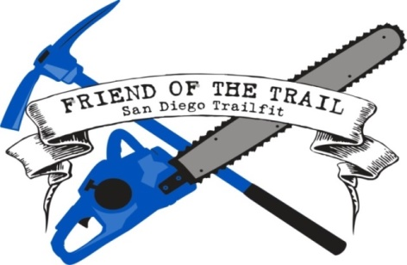
http://www.sdtrailfit.org

- The San Diego Trailfit Program headed by Ken Bonus provides the management and leadership to maintain and oversee most all of the trails for the SD 100 as well as other trail runs in the east county mountains of San Diego. We hope and encourage all local San Diego area participants accomplish their volunteer service requisite by signing up online for SDTrailfit.

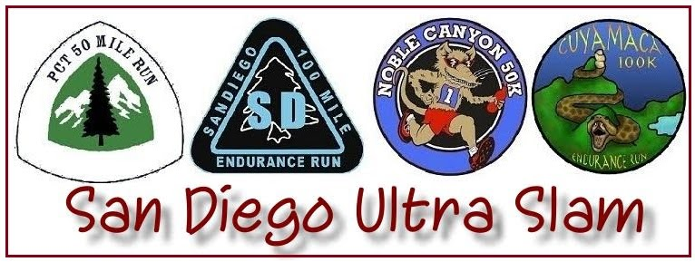

http://www.sandiego100.com/sanDiegoUltraSlam.asp

- The San Diego Ultra Slam is composed of four San Diego ultra- marathons. To be eligible for the award, participants must complete each race in the calendar order they occur. However, you may choose whichever race you wish to start with. Each race offers a different distance and distinct challenge to the participant, and running all four within one year represents a significant achievement. Your accomplishment will be memorialized on this site, and your award will be presented to you at the conclusion of your final race.

- Online SD 100 Merchandise Sales is located at:
http://squareup.com/market/sd100-merchandise

- Weather Link for Julian, CA:
https://weather.com/weather/tenday/l/USCA0530:1:US

